**iPRIMED Education Solutions Private Limited**



**PROJECT REPORT**

**ON**

**“BANKING MANAGEMENT SYSTEM”**

**Submitted by**

**(Team 06)**

**Chinmay M**

**M. Suma Rani**

**Raghu Hs**

**Ashok Kumar Sharma**

**FROM**

**HARMAN C++ BATCH- 06**

**1**

**ABSTRACT**

The Bank Management System is an application for maintaining a person's account in a bank. In this project we tried to show the working of a banking account system and cover the basic functionality of a Bank Management System. To develop a project for solving financial applications of a customer in banking environment in order to nurture the needs of an end banking user by providing various ways to perform banking tasks. Also to enable the user’s workspace to have additional functionalities which are not provided under a conventional banking project.

The Bank Management System undertaken as a project is based on relevant technologies. The main aim of this project is to develop software for Bank Management System. This project has been developed to carry out the processes easily and quickly, which is not possible with the manuals systems, which are overcome by this software.

**2**

**TABLE OF CONTENTS**

|  |  |  |  |
| --- | --- | --- | --- |
| **SR NO** | **CHAPTER NO.** | **TITLE** | **PAGE NO** |
| **1.** | **Basic Details on Project** |  |  |
|  |  | Introduction | **4** |
|  |  | Background of the project | **5** |
|  |  | Project Objectives | **5** |
|  |  | Problem Statement | **6** |
|  |  | Proposed Solution | **6** |
| **2.** | **Goals of the project** |  | **7** |
| **3.** | **Features of the project** |  | **7** |
| **4.** | **UML Diagrams** |  | **8-9** |
| **5.** | **Architecture Diagrams** |  | **10** |
| **6.** | **Functionalities of the project** |  | **11** |
| **7.** | **Requirements specification** |  | **12** |
| **8.** | **Queries and Application Glimpse** |  | **13-16** |
| **9.** | **Conclusion** |  | **17** |

**3**

**INTRODUCTION**

The “Bank Management System” project is a model Internet Banking Application. This enables the customers to perform the basic banking transactions by sitting at their office or at homes through PC or laptop. The system provides the access to the customer to create an account, deposit/withdraw the cash from his account, also to view reports of all accounts present. The customers can access the banks website for viewing their Account details and perform the transactions on account as per their requirements. With Internet Banking, the brick and mortarstructure of the traditional banking gets converted into a click and portal model, thereby giving a concept of virtual banking a real shape. Thus today's banking is no longer confined to branches. E-banking facilitates banking transactions by customers round the clock globally.

The primary aim of this “Bank Management System” is to provide an improved design methodology, which envisages the future expansion, and modification, which is necessary for a core sector like banking. This necessitates the design to be expandable and modifiable and so a modular approach is used in developing the application software. Anybody who is an Account holder in this bank can become a member of Bank Management System. He has to fill a form with his personal details and Account Number.

**4**

**Background of the project**

Creating a database for organizing and storing data received through web applications with bank customer data. And for fetching the most recent data from the database (Clients Database). The data stored in the DB must be organized and maintained in such a way it caters to the needs of the future. All the customer data are viewed in an arranged manner according to the registered account numbers.

**PROJECT OBJECTIVES**

The goal of the bank management system project is to create an organic and optimal software of interaction between the various banking components. This is to maximize the profit of the banking mechanism. The implementation of competent bank management procedures is significantly responsible for the successful optimization of the bank’s product

The project’s main goal is to create an online banking system for banks. All banking work is done manually in the current system. To withdraw or deposit money, the user must go to the bank. Today, it is also hard to find account information for people who have accounts in the banking system.

**5**

**PROBLEM STATEMENT**

The problems occur when there is no digital records because of all paperwork some of them are mentioned which are: File lost / damaged, Human error, Space consuming and Cost consuming. File lost because of human environment. File damaged when a computerized system is not there, file is always lost due to some accident like of water by some member on file accidentally. Besides some natural disaster like floods or fire may also damage the files. Due to some human error there may be loss of records. Difficult to search record when there is no computerized system, there is always a difficulty in searching of records if the records are large in number. Space consuming as it requires physical storage. As there is no computerized system to add each record paper will be needed which will increase the cost the management of system.

**Proposed Solution**

In our proposed system we have the provision for adding the details of the students by themselves. So the overhead of the school authorities and the teachers has become less. Another advantage of the system is that it is very easy to edit the details of the student and delete a student when it is unnecessary.

Our proposed system has some advantages:

* User friendly interface
* Fast access to database
* Less error
* More storage capacity
* Search facility

**6**

**Goals of the project**

* To manage details of profiles, courses, Logins, Transactions.
* Proper retrieval of the account holder’s information with other details.
* Data integrity, privacy and security can also be protected in an open-access environment.
* To reduce unnecessary paperwork in maintaining customer information.

**Features Of Project:**

* **Create Account**– The user needs to create new account first to get a unique account number to login.
* **Login**– After creating an account, The user need to login first to enable to access the system.
* **Manage Account** – The user can view his/her account status such account number, current balance in your account, and the account type.
* **Money Transfer** – The user can transfer money from one bank account to another bank account.

**Manage Profile** – The user can edit details information and can change password.

**7**

**UML Diagrams**

**Use Case Diagram**

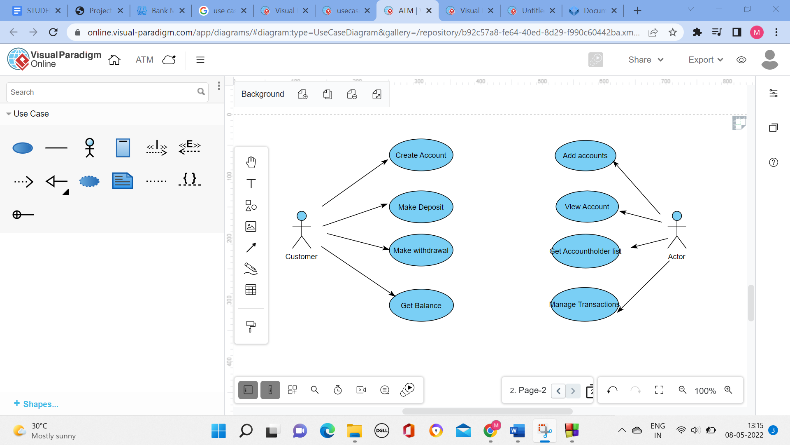

**Database Table**

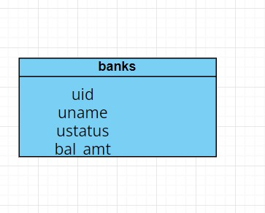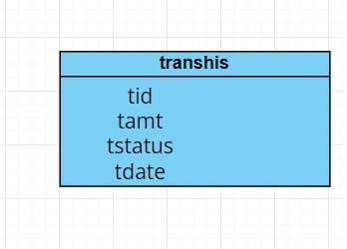

**8**

**Activity Diagram**

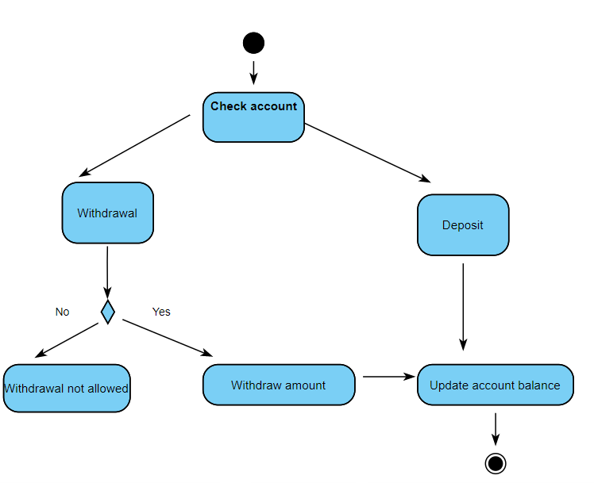

**Class Diagram**

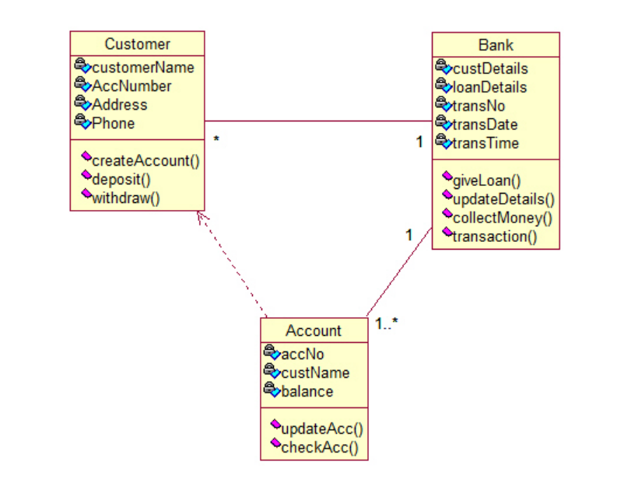 **9**

**Architecture Diagram**

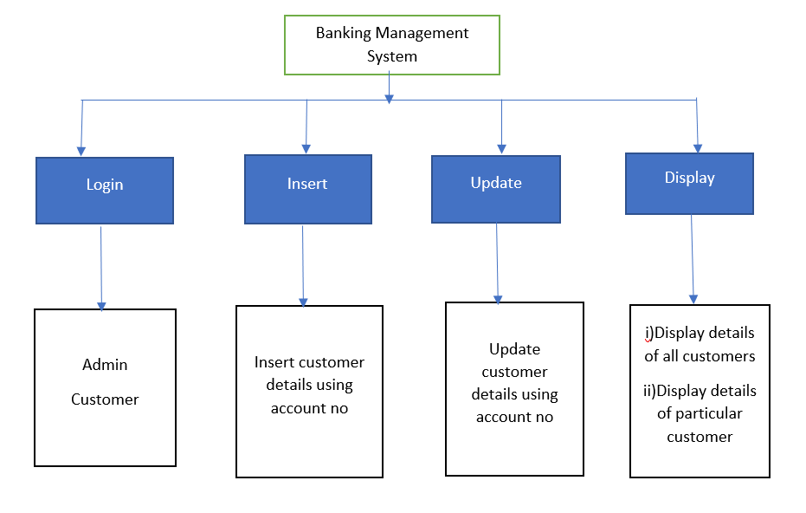

**10**

**How does the application work?**

* The Basic Bank Management System is a simple console program that allows you to access all of the system’s features by entering the system password.
* The user has several options in the system, including creating new client accounts, depositing cash, withdrawing cash, and changing account information.
* The system will offer you the tools you need to manage your bank accounts. Your data will be saved as a data file extension by the system.

**11**

**REQUIREMENTS**

**Hardware Requirements:**

● Processor: Intel P-IV System

● Processor Speed:250 MHz to 833 MHz

● Ram: 512 Mb Ram

● Hard Disk : 40 GB

**Software Requirements:**

● Window/Linux Based OS/Mac OS/ Any OS capable of running C++

● MySQL database

● XAMPP server

● Code::Blocks IDE

**12**

**SQL QUERIES And C++ Code**

**Bank Account Holder Table Create Query:**

CREATE TABLE `banks` (

`uid` int(7) UNSIGNED ZEROFILL NOT NULL,

`uname` varchar(255) NOT NULL,

`ustatus` varchar(255) DEFAULT NULL,

`bal_amt` int(11) NOT NULL

) ENGINE=MyISAM DEFAULT CHARSET=latin1;

**Account Holder’s Transaction Table Create Query:**

CREATE TABLE `transhis` (

`tid` int(11) NOT NULL,

`tamt` int(11) NOT NULL,

`tstatus` varchar(100) NOT NULL,

`tdate` varchar(200) NOT NULL

) ENGINE=MyISAM DEFAULT CHARSET=latin1;

**Deposit and Withdraw C++ Code**

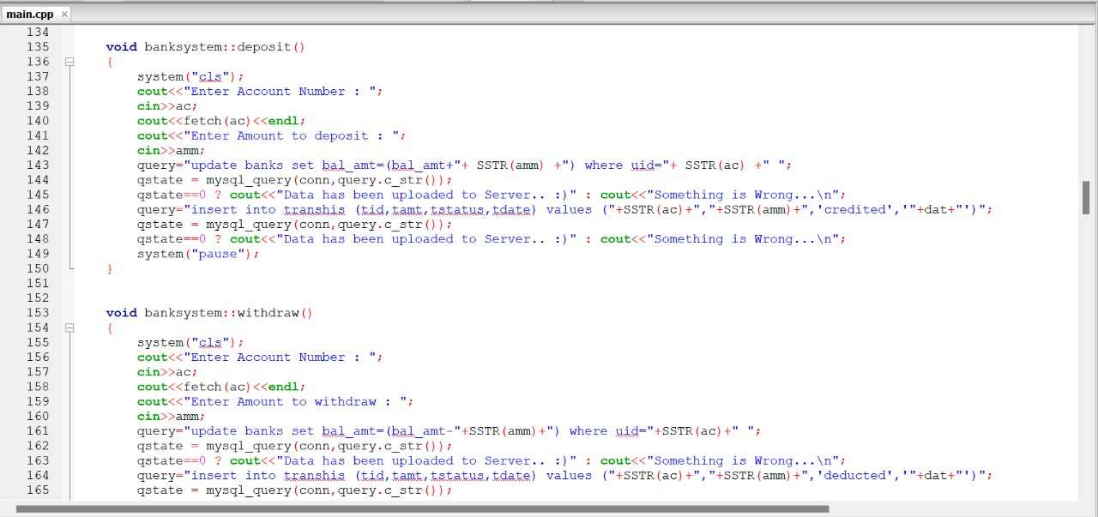

**13**

**GLIMPSE OF THE APPLICATION**

**Root Login**

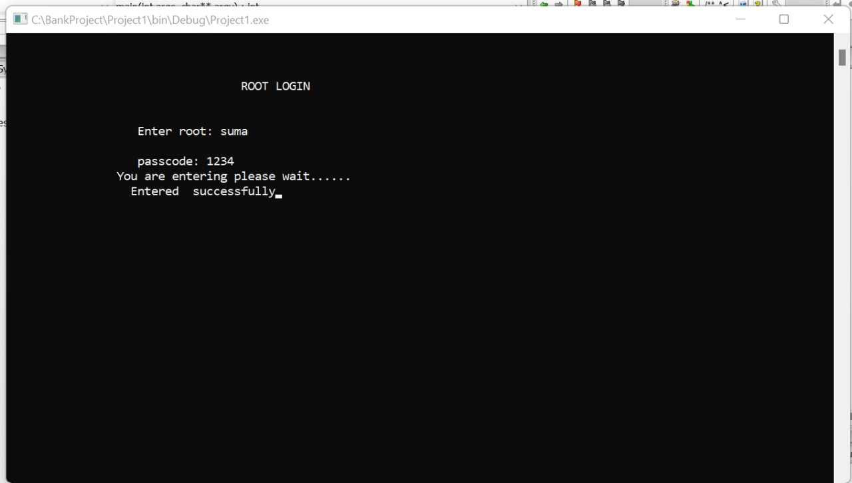

**Home Console**

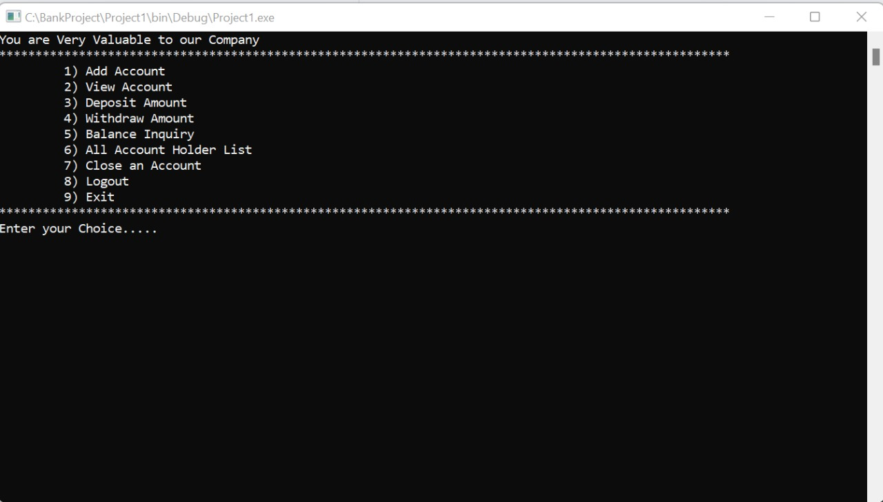

**14**

**Amount Deposit**

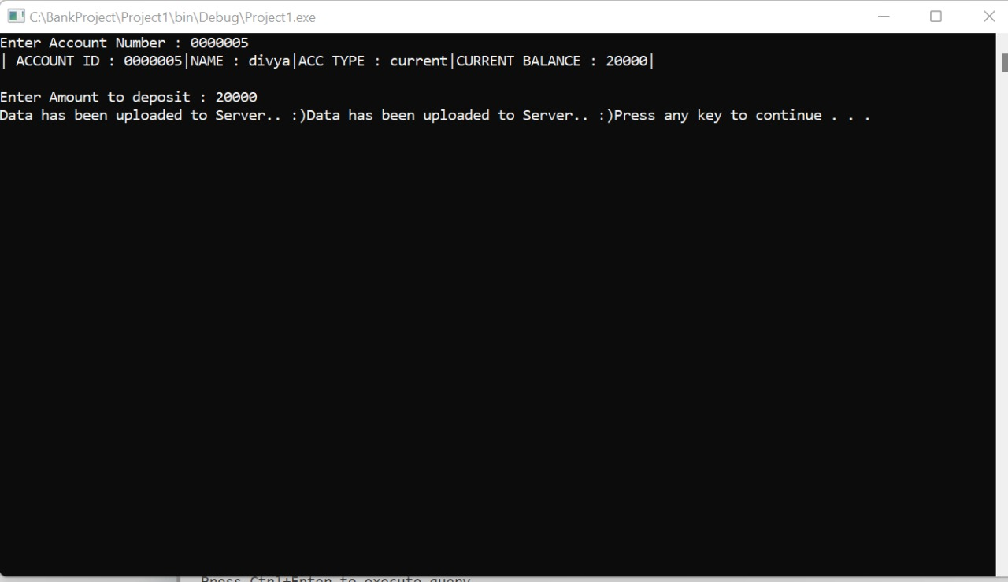

**Amount Withdrawal**

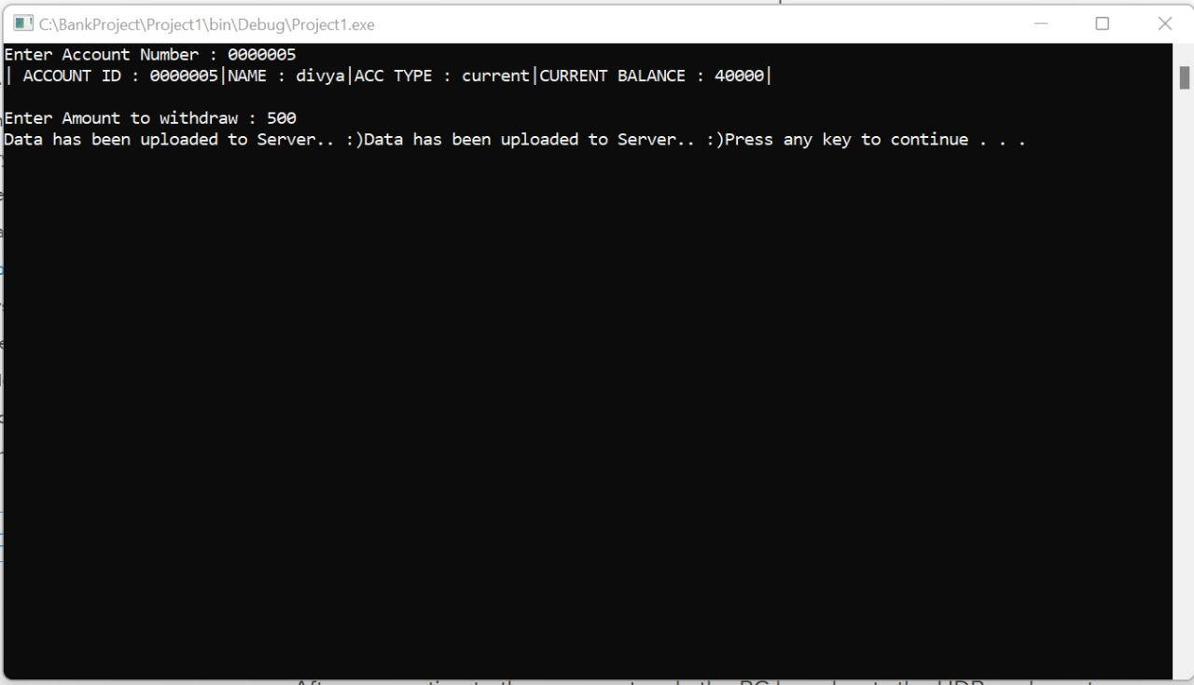

**15**

**Display Account Holder List**

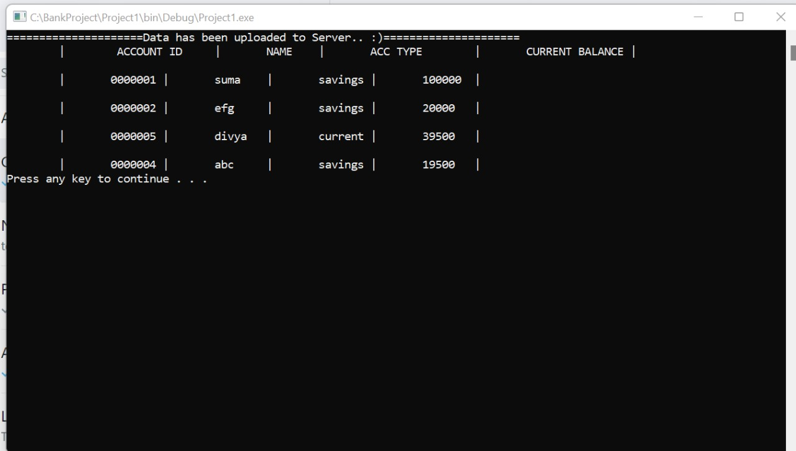

**SQL Database of Account Holders**

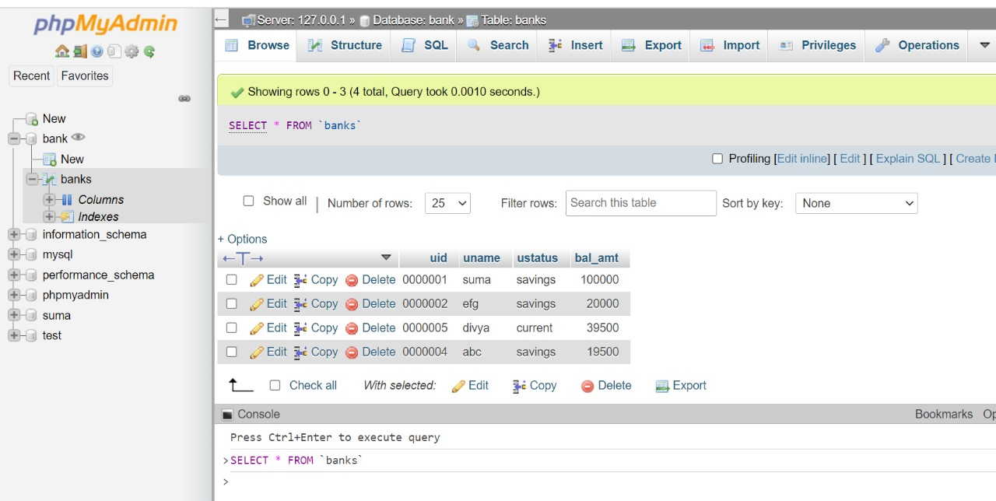

**16**

**CONCLUSION**

The goal of this research was to create a bank management project system that would aid in the maintenance of bank users’ records. It has the ability to handle all the transactions done with the client’s financial matters. The project must have tight security to secure the financial records of all the bank clients.

That ends our elaboration on Bank Management System Project Report and documentation.

**17**